2.93: The velocities are 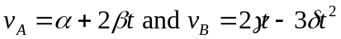a) Since v_{B} is zero at t = 0, car A takes the early lead. b) The cars are both at the origin at t = 0. The non-trivial solution is found by setting x_{A} = x_{B}, cancelling the common factor of t, and solving the quadratic for

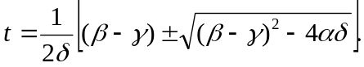

Substitution of numerical values gives 2.27 s, 5.73 s. The use of the term “starting point” can be taken to mean that negative times are to be neglected. c) Setting v_{A} = v_{B} leads to a different quadratic, the positive solution to which is

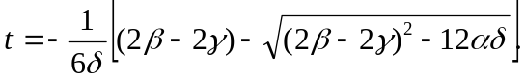

Substitution of numerical results gives 1.00 s and 4.33 s.

d) Taking the second derivative of x_{A} and x_{B} and setting them equal, yields, 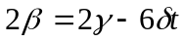. Solving, 

